Edward Hopper was most part of the art movement known as realism. This movement began in france during 1850. Realist artist rejected romanticism instead want to poetry real people in real situations. Realism ended around the time impressionism began to arise. Many of the works involve ordinary people in ordinary surroundings. It helped American realism by depicting daily life of the poorer members of society. Hopper was a softer realist, he used simplified shaped and designs.
Edward Hopper was born on July 22, 1882 in Upper Nyack, New York. He is most famous for his oil paintings, but was recognized for his watercolor. Hopper paid attention the geometrical design and place the human figures carefully as to properly balance them with their environment. Taking things slow he would never approach the easel thill he had everything planned out in his head. Hopper uses light and shadows to depict the moods of his work, the effect of this was compared to cinematograph, Hopper placed the people as if the scene was captured right before the climax of the moment.
Hooper’s most famous work is Nighthawks painted in 1942. This piece depicts three people sitting at an all night dinner and the person working it. The view of the pieces is from outside and down the street as if the viewer is walking up to it. The bright lights from inside contradicts with the darkness of outside. The three customers in the dinner have little to no interactions which continues one of Edward Hopper’s common theme, loneliness.This piece is very popular within pop culture because of the countless parodies made of it with famous fictional characters. Another one of his works is titled Rooms by the sea painted in 1951. Its an empty room with an open door that appears to lead straight to the ocean, the sunlight cast a spectaculair shadow on the wall by the door and farther into the building. On the left side there is a doorway inside the house that leads to a sitting room where the light from a window cast a similar shadow into the room. The colors inside are plain and dull like the white wall, tan floor and brown shadow, compared to the bright brilliant blue that Hopper used for the ocean and the light blue grey he used for the sky.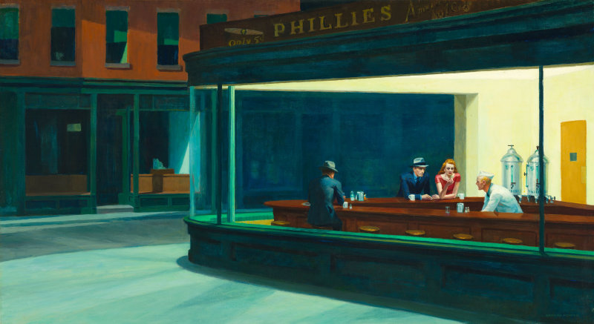Nighthawks, 1942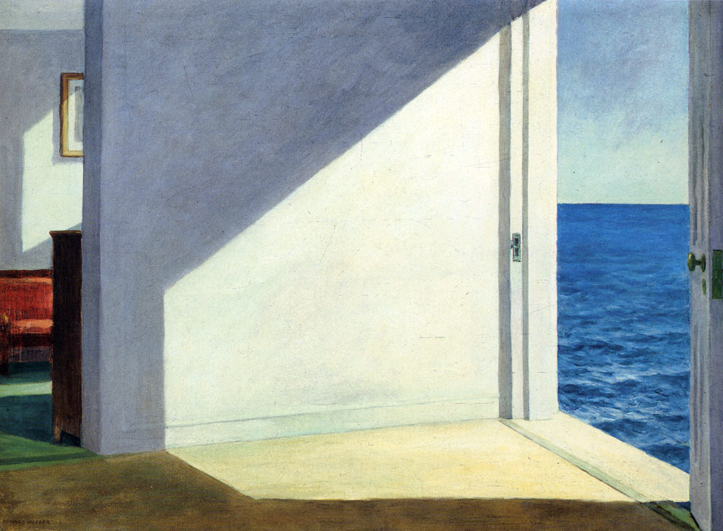 Rooms by the sea, 1951

